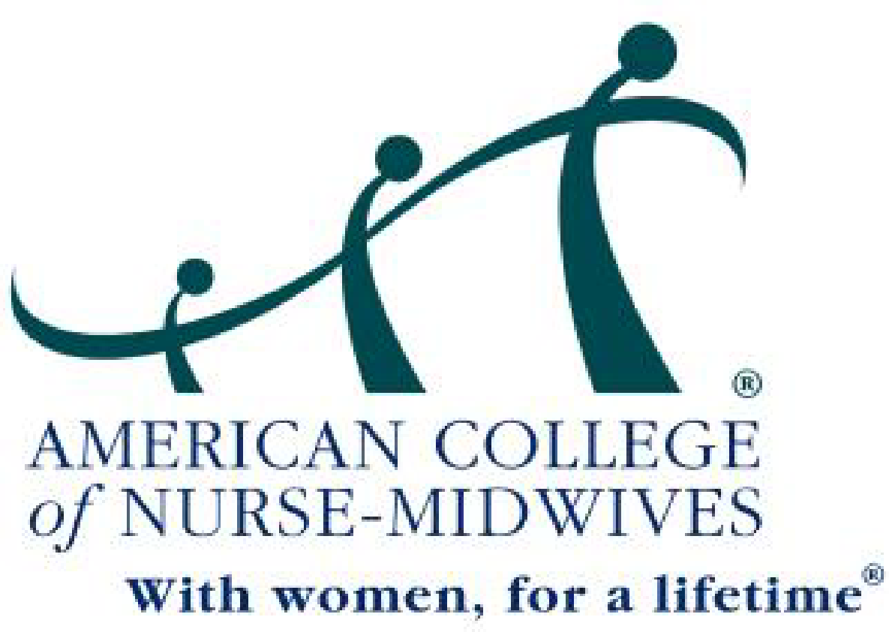

Continuing Education
Program Sponsor Application
2020

Supporting a Learning Experience Beyond Basic Midwifery Education.

TABLE OF CONTENTS

I. Introduction Page 2
ACNM Definition of Continuing Education

II. Guidelines for ACNM Approval of Programs for CE Page 4
Activities not intended to receive CE
Pharmacologic Content

III. The ACNM CE Approval Process Page 6
Program Approval
Issuing Certificates of Attendance & Record Maintenance
Determining the Number of contact hours (CE) to be Awarded
Calculating CE for Alternative Delivery Methods

IV. Submitting A Program Sponsor Application Page 8
Deadlines for Application Packet and Fee
Language for Promotional Brochures
Application fees
Session Format Outline

V. Additional Information Page 12

VI. References Page 12

VII. ACNM Program Sponsor Application Processing Cover Form Page 13

VIII. The Application Checklist Page 14

ACNM is the provider and approver of ACNM CE credit.

ALL ACNM APPROVED CE PROGRAMS MUST:

Go beyond the current ACNM Core Competencies for Basic Midwifery Practice OR

Show new learning DIRECTLY RELEVANT TO or impacting CNM/CM practice AND

Include APA or AMA formatted documentation of references that meet the minimum requirement for length of presentation.
- INTRODUCTION

This application packet is for a Program Sponsor Application to the American College of Nurse-Midwives (ACNM) for program approval of Continuing Education (CE). The ACNM is the professional association for the Certified Nurse-Midwife (CNM) and Certified Midwife (CM). The Continuing Education Committee (CEC) of the ACNM has been assigned the responsibility for reviewing and approving all educational programs seeking ACNM CE credit. Only programs approved by either the CEC or organizations with which ACNM has approved CE reciprocity are awarded CEs officially recognized by the ACNM. This does not imply individual state recognition for nursing CEs.

ACNM Definition of Continuing Education

The complexity of knowledge and skills in today's midwifery practice make it essential for CNMs and CMs to have continuing education following their initial certification. Continuing education is defined by the ACNM as a learning experience beyond basic midwifery education, intended for CNMs/CMs.

Continuing education is considered formal education programs/activities for professional development and training, or for credentialing, for which academic credit is not awarded. The educational experience should be designed to enlarge upon and go beyond the professional knowledge and skills learned in a midwifery education program, refresher course or internship, and/or be outside of or in addition to routine professional educational obligations, basic skill updates, and responsibilities. ACNM approved CE activities should promote professional goals for increased competency and excellence in skills directly associated with the practice of midwifery and be characterized by programs designed to introduce newly emerging concepts, principles, theories, and research in healthcare directly impacting the midwifery profession. While midwives may also benefit from educational opportunities offered by a variety of associated professional fields, those not directly applicable to the practice of midwifery are not eligible for ACNM continuing education credit. This statement in no way is meant to imply that these programs are without merit.
The Continuing Education Committee of ACNM accepts Continuing Education credit that has been awarded by the following organizations:

ACCME (Accreditation Council for Continuing Medical Education) Category 1
AMA (American Medical Association) PRA Category 1
AAFP (American Academy of Family Physicians)
AANP (American Academy of Nurse Practitioners)
NPWH (National Association of Nurse Practitioners in Women’s Health)
ACPE (Accreditation Council for Pharmacy Education)

If a program has received prior CE approval from a CE certifying organization with which ACNM has reciprocity (listed above), it will not be reviewed for ACNM.

The Continuing Education Committee will consider programs for CE approval in accordance with ACNM position statements and, additionally, in alignment with advanced skills that may be added to a CNM/CM’s scope of practice, such as, advanced suturing, sonography, language programs focusing on medical terminology in a foreign language, and computer usage specifically designed to increase access to professional information.

Continuing Education is not awarded for programs that promote a commercial product or program, such as childbirth education training (examples: BirthWorks Trainer Workshops [however, a conference sponsored by BirthWorks is eligible for review], Transcendental Meditation, CenteringPregnancy, Lamaze), for basic skills, or those routinely required for work responsibilities, such as, BLS for Healthcare Providers/ACLS or Neonatal Resuscitation Program (NRP). However, if the program is reporting evidence-based practice or research information about a particular mode of CB education, then CEs may be awarded. For example, research on the benefits/outcomes of CenteringPregnancy will be reviewed for CE approval.

Documents you may find useful in developing programs for midwives are:

ACNM Core Competencies for Basic Midwifery Practice
ACNM Definition of Midwifery and Scope of Practice of Certified Nurse-Midwives and
Certified Midwives
ACNM Standards for the Practice of Midwifery
ACNM Position Statement: Expansion of Midwifery Practice and Skills Beyond
Basic Core Competencies
Philosophy of the American College of Nurse-Midwives

- These documents are available online at http://www.midwife.org

ACNM approved CEs are accepted for certification maintenance by AMCB. The ACNM has been granted provider numbers by Boards of Nursing in Alabama (ABN 80077), California (BRN02902) and Florida (27F1686) for ACNM-sponsored continuing education activities only. ACNM CE approval does not indicate approval by these state Boards of Nursing.

II. GUIDELINES FOR ACNM APPROVAL OF PROGRAMS FOR CE

The ACNM Continuing Education Committee follows the principles expressed in The Continuing Education Criteria and Guidelines of the International Association for Continuing Education and Training (IACET), including alignment with the criteria that represent the minimum requirements for awarding CE credit (Phillips, 2009):

- Each activity is planned in response to educational needs that have been identified for a target audience.

- Each activity has clear and concise written statements of intended learning outcomes based on identified needs of the audience in knowledge, skills, or attitudes.

- The program sponsor provides an appropriate learning environment and support services.

- Qualified instructional personnel are involved in planning and conducting each activity.

- Content and instructional methods are appropriate for the intended learning outcomes of each learning activity.

- Assessment must be performed to determine if learners have mastered each learning outcome related to the knowledge, skill, or critical thinking required to solve the problem, task, or project that is presented.

- The program sponsor maintains a complete record of each individual's participation and is able to provide a copy of that record upon request for a period of at least seven (7) years.

- The program sponsor will provide learners the ability to give feedback evaluating overall program effectiveness and that of each learning activity based on multiple criteria.

Activities not intended to receive CE according to IACET include:

- Academic credit courses
- Association membership and leadership activities
- Committee meetings
- Entertainment and recreation
- Individual scholarship
- Mass media programs (unless planned according to CE standards)
- Some meetings, conventions, exhibitions (unless planned according to CE standards)
- Travel
- Unsupervised study
- Work experience
- Youth programs

Pharmacologic Content

ACNM encourages program sponsors to specifically indicate all continuing education time dedicated to pharmacologic content within a given activity in quarter hour increments. Please be advised that although pharmacologic content should be indicated on your application and the participants’ certificate of attendance, ACNM will not be awarding a separate pharmacologic CE outside of the basic ACNM CE. Pharmacologic credit is designated as RxCE (e.g., 1 RxCE)

III. THE ACNM CE APPROVAL PROCESS

Each application is reviewed by at least one volunteer CNM/CM member of the ACNM Continuing Education Section Reader Panel. If rejected by one reader, it is automatically sent for review by a second senior reader. Programs that are rejected may be appealed once (see below). The readers have the following options for determining whether an application meets the guidelines for approval:

Accepted: The program application is complete and clearly meets the guidelines for ACNM approval of CE.

Declined: The program application is complete but clearly does not meet the guidelines for ACNM approval of CE.

Conditionally Accepted: The program application appears to meet the guidelines for ACNM approval of CE but requires submission of additional documentation requested by the reader to make a final determination. Approval will be granted pending receipt of the requested information.
Partial Program Accepted: Certain sessions or sections of the program clearly meet the guidelines for ACNM approval of CE while the remaining sessions or sections clearly do not meet the guidelines.

Readers' names are never released to the program applicant. Program applicants may appeal a rejected application in writing to the Continuing Education Committee Chair c/o ACNM. An appealed application will be reviewed independently by a third reader. Decision of the third reader is final. No further appeals will be considered.

Program Approval

Programs approved for ACNM CEs are valid for two years from the date of approval notification. The program sponsor does not need to notify ACNM if the program is going to be repeated during the two-year time period.

Occasionally, program sponsors may desire to award CE credit for individual sessions presented independent of an approved multi-session program. Each individual session is evaluated and, if approved, is assigned a distinct education session (ES) number. When presenting individual sessions, the sponsor should indicate the individual session(s) number attended. For example, education session 2 from Program 2020/95 is presented at an affiliate meeting. The certificate should note the participant has earned a CE for 2020/95/ES2.

Issuing Certificates of Attendance & Record Maintenance

The certificate should include the following information:

- ACNM program number
- Name and address of the sponsor with individual presenter(s) name(s)
- Title of the course and activity
- Completion date of the activity
- Number of ACNM approved CE hours awarded (e.g., 1 CE)
- Time allotted for included pharmacologic content (e.g., .5 RxCE)

If pharmacologic content is included, the number of hours dedicated to this topic should be stated separately on the certificate of attendance but are included within the total number of CEs awarded. A certificate of attendance may not be considered a substitute for maintaining a record of participants' attendance. Attendees should only claim contact hours equal to the time actually spent in the activity.

In compliance with the IACET criteria for granting CE, it is the program sponsor's responsibility to maintain a record for 7 years of CNM/CM program participants that includes the information listed above and an identifying number for the participant, such as the participant’s certification number. It is not necessary to send to ACNM an attendance list or program evaluation form upon completion. The ACNM does not maintain a database of program participation for individual CNMs/CMs.

Determining the Number of CEs to be Awarded
One continuing education credit (CE) is awarded for each 60-minute clock hour (i.e., contact hour).

60-minute clock hour = 1 contact hour
1 contact hour = 1 CE
The term “Continuing Education Unit” (indicating 10 contact hours) will no longer be used to designate hours earned on certificates.

When the fractional part of an hour is at least 5/6 (50 minutes or more) the fractional portion should be counted as one whole hour. Any portion of an hour between 30 and 44 minutes should be counted as 30 minutes (.5 CE). Any amount less than 30 minutes is not awarded credit.

Workshop (WS) credit is awarded as follows:
4-hour WS = 3.5 CEs; 8-hour WS = 6.5 CEs; 9-hour WS = 7.5 CEs

Pharmacology CE is awarded in quarter-hour increments (i.e., 0-14 minutes= 0 credit; 15-29 minutes = .25 RxCE; 30-44 minutes = .5 RxCE; 45-55 minutes = .75 RxCE; >60 minutes = 1.0 RxCE).

ACNM CE programs are not evaluated and awarded retroactively.

Calculating CE for Alternative Delivery Methods

The growing trend of delivering courses and programs to learners independent of a live instructor raises questions about how CE should be calculated. Examples of such delivery methods include independent study packages, online programs, videos, field and laboratory experiences, and assigned work outside of class. In most cases the amount of time required for the completion of learning activities with these delivery formats varies from one learner to another. In courses or programs where participants learn and progress at their own pace, the sponsor should establish a standard number of contact hours based on an average number of hours required by several initial representative learners to complete the program. Homework or practice time is not included in the CE calculation unless the program includes an evaluation of participants’ learning.

IV. SUBMITTING A PROGRAM SPONSOR APPLICATION

For your program to be considered by the ACNM for CE approval, the following must be submitted:

- The application, which includes the processing cover form, session(s) format outline(s), references in APA or AMA format, sample program evaluation tool, certificate of attendance, program brochure or other promotional material (if available), and checklist. For programs including homework or practice time, the process for evaluation of participants’ learning must be included.

- Application fee

- Please send to:
    - By email: ceu@acnm.org
    - By mail: Membership and MPEGO Coordinator
American College of Nurse-Midwives
8403 Colesville Rd., Suite 1550
Silver Spring, MD 20910-6374

Deadlines for Application Packet and Fee

Programs 1-2 hours in length: Due 45 days prior to program start date.
Programs longer than 2 hours: Due 60 days prior to program start date.

Due dates ensure notification of program approval status prior to the program’s start date. Incomplete applications (e.g., lack of APA or AMA reference formatting) will delay the approval process. Click here for an example of APA and AMA formatting. Program approval prior to the anticipated start date cannot be guaranteed for any application received after specified deadlines. This applies as well to an application submitted prior its deadline but returned to the sponsor due to an incomplete/incorrect submission and the corrected application received once again then sent out for review after the designated deadline. Returned applications can be avoided by thoroughly completing the checklist on page 14 of this application.

Language for Promotional Brochures

Sponsors may not indicate in brochures, announcements or other printed matter that ACNM CE is pending. The proper designation should state, “ACNM specialty credit has been applied for.”

Application Fees

Applications received without the appropriate fee will not be processed until the fee is received at the ACNM national office. Checks and money orders should be made payable to the ACNM.

Programs/Workshops one day or less in length
Commercial and for-profit corporations $250.00
Non-profit organizations * $200.00
ACNM Affiliates, Regional Meetings, or $50.00
ACME Accredited Midwifery Education
Programs

*Non-profit organizations must provide their tax-exempt ID number on the application after the
Sponsoring Organization name.

Additional program days $75 each add’l day
For example: an ACNM Affiliate that is hosting a 3-day continuing education program would pay $50 (Day 1) + $75 (Day 2) + $75 (Day 3) = $200

Session Outline Format

Each session must contain all outlined parts:

Part 1 Session Title

Part 2 Session Length and Pharmacology Minutes (if any)
Total contact hours (30-minute increments) and pharmacology minutes, if any (15-minute increments) should be specified for each program session based on the formula described in Determining the Number of CEs to be Awarded (page 7). Pharmacology content credit is to be included within total CEs awarded.
- Contact hours designated as CEs (e.g., 4 CEs equals 4 contact hours)
- Pharmacology minutes designated as RxCEs (e.g., .25 RxCE equals 15-29 minutes)
The following activities should not be included when calculating contact hours for CE: breaks, meals, socials (presentation germane to the course during a meal function may be counted); meeting time devoted to business or committee activities, question/answer period >10 minutes per contact hour, announcements, introductions, welcoming speeches, reports, etc.; time for study, travel, assigned reading, or related activities outside the classroom or meeting schedule unless the activity is monitored and/or assessed while being performed or the learning is formally evaluated (e.g., multiple choice test at conclusion of the activity).

Part 3 Teaching/Delivery Methods
Examples of teaching methods are lecture, home study, online - live or recorded, and panel discussions.

Part 4 Learning Objectives
The learning objectives serve to clearly outline what the participant will learn as a result of attending this session. List three to six objectives (as appropriate) for each 1-hour session. Sessions longer than 1-hour should have sufficient objectives to address all topics covered. Each objective must be stated in terms of learner outcome, i.e., “At the conclusion of this session, participants will be able to ....”. How to write a learning objective

Part 5 Content Outline of Session(s)
The outline should be relevant to each objective. The outline, objectives, and reference list must support each other and be directly related. For each content area, note the number of minutes designated to cover each of the session’s topics, noting any pharmacology minutes as well.

The learning objectives should provide a good indication in regard to the level of the content. If the objectives only specify content covered within a basic midwifery education program then the program is not beyond core competencies. In order for a program to go beyond core competencies or to provide updated information, no more than 25% of the session should be a review and/or cover knowledge that has been in practice or can be found in professional literature published more than five years ago.

If the program consists of more than one session, each session must be presented separate from the others and will be assigned a unique CE number. For example, a program contains three sessions. Session 1 is presented in its entirety, then information for Session 2 and, finally, Session 3.
Part 6 Reference List
Each session must include a reference list to support the session topic.
A majority of the minimum number of required references for a session’s length must have been published in peer-reviewed journals within the last 5 years for a session to be considered. Additional references may include those not meeting the 5-year criteria and/or are from respected professional sources not peer-reviewed. Noted classics will be accepted. Articles published by the presenter may be included.

All references MUST be cited in either APA or AMA style. This criterion is not optional. Program submissions not meeting the minimum criteria and/or not formatted in APA or AMA style will be returned for correction without review. Once corrected, the program may be returned for review without penalty. Click here for an example of APA and AMA formatting.

Example:
- 1-hour presentation must include a minimum of 6 references (at least 4 of which have been published within the last 5 years in a peer-reviewed journal).
- 4-hour presentation must include a minimum of 10 references (at least 6 of which have been published within the last 5 years in a peer-reviewed journal).
- 8-hour presentation must include a minimum of 12 references (at least 7 of which have been published within the last 5 years in a peer-reviewed journal).

For presentations of a historical nature, discretion of the reviewer is permitted to determine if the literature cited reflects appropriate citations. It is recommended that references are included that have been published in peer-reviewed journals within the last 5 years which are relevant to the presentation, if available. When historical methodology is used, many of the sources in the bibliography date from the period of study. This is often true for many of the primary sources but may also relate to the secondary source material as well. The author should give a clear and comprehensive explanation of the references and their significance to the study so that the reviewer will see that the reference material is relevant and appropriate to the presentation.

Part 7 Faculty Bio-sketch
Examples of faculty include presenters, authors, editors, moderators, etc. If the presenter’s expertise on the topic is evident from the CV, it is acceptable to simply attach the presenter’s CV. However, if the CV does not clearly reflect the presenter’s expertise, a bio-sketch (one page maximum) must be included that describes his/her professional knowledge base, skill, and/or experience related to the topic. The bio-sketch may be submitted in a narrative form and should include the faculty’s credentials, educational background, work experience, research, and publications/presentations relevant to the current topic being presented.

Part 8 Prior/Other CE Approval
If any session currently being submitted for approval has received prior approval or approval from another organization, please indicate this below and include the ACNM program number.

V. ADDITIONAL INFORMATION

Questions? Call the ACNM CE Department at (240) 485-1824 or email mlowe@acnm.org

VI. REFERENCES

American Midwifery Certification Board. (2019). Continuing education policy.
Linthicum, MD: Author. Retrieved from
https://www.amcbmidwife.org/certificate-maintenance-program/continuing-education-policy

Phillips, L. (Ed.). (2009). The continuing education guide: The CEU and other
professional development criteria (2nd ed.). (n.p.): Author.

Phillips, J.L., Heneka, N., Bhattarai, P, Fraser, C., & Shaw, T. (2019). Effectiveness of the spaced education pedagogy for clinicians' continuing professional development: A systematic review. Medical Education. Advance online publication. doi: 10.1111/medu.13895.

VII. ACNM Program Sponsor Application Processing Cover Form

Program Title:

Sponsoring organization:

Contact person:

Address:

Preferred phone # Fax

Site of Presentation:

Date of Presentation:

If independent study, please check one of the following:
 home study  audio/video  online  other:

Number of separate sessions being considered for CE approval for this program:

Total number of contact hours (CEs) offered within the entire program
(in 30-minute increments):

Is pharmacologic content included in the program?  Yes  No

Total number of pharmacology hours (RxCEs) for the entire program (in 15-minute increments):

Method of recording and verifying attendance (attach sample copy):
 Sign-in Sheet  Post-test Questions  Other:

Attachments: (1) Program Evaluation (sample copies required)
(2) Certificate of attendance (sample)
(3) Brochure or other promotional material (attach copies, if available)
Please submit learning objectives, content outline, references, and speaker information (if different) for each session CE approval is requested.

VIII. APPLICATION CHECKLIST

Please review the following checklist to ensure that all of the required items are included. Incomplete applications will be returned for completion.

 Application Fee

 Completed Processing Cover Form

 Program Evaluation Tool

 Certificate of attendance (sample)

 Promotional brochure (if available)

 PDF file for each session submitted for approval:
 Session(s) title(s)
 Session(s) length (30-minute increments; noted as CEs)
 Pharmacology minutes (15-minute increments; noted as RxCEs)
 Instructional delivery methods
 Learning objectives
 Content outline
 Reference list in APA or AMA format Click here for an example of formatting.
 Bio-sketch or CV of presenter(s) (Bio-sketch if required to clarify topic expertise)
 Prior session approval (if applicable)

 All programs must provide a balanced view of therapeutic options, use generic drug names and/or trade names of the products of several companies, be objective in reporting research and disclose unlabeled use of commercial products. Programs are not permitted to promote a business or financial endeavor of the presenter.

Please sign and date below. Signing the checklist ensures that every application requirement has been met. Please include the signed checklist with the application material being submitted for approval.

PROGRAM SPONSOR/COORDINATOR DATE

