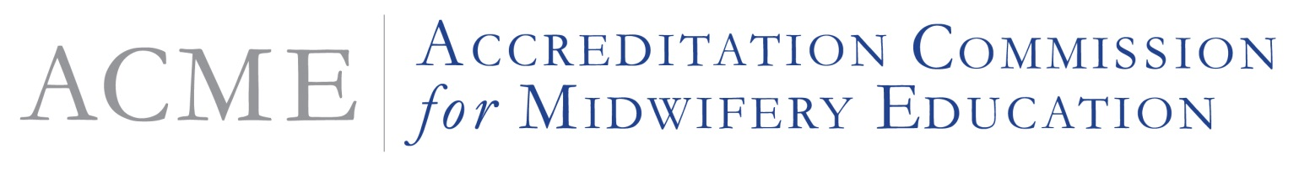
8403 Colesville Road, Suite 1550 • Silver Spring, MD 20910-6374 • Phone: 240.485.1802 • www.midwife.org/acme

NOTICE OF ACCREDITATION ACTION
February 16, 2018

Accrediting agencies recognized by the U.S. Department of Education (USDE) are required to notify regional accreditors, selected specialized accreditors, regional institutional accreditors, and state licensing agencies responsible for post-secondary education of final accreditation decisions. In addition, the Accreditation Commission for Midwifery Education (ACME) also provides notice of its accreditation decisions to the public on its website.

In accordance with 34 CFR §602.26(a), you are being provided with notice of these actions no later than 30 days following the Commission decision. Please be advised that ACME, the recognized accrediting agency for the accreditation and pre-accreditation of basic certificate, basic graduate nurse-midwifery, direct entry midwifery, and pre-certification nurse-midwifery education programs, including those programs that offer distance education, took the following actions at its Board of Review (BOR) meeting February 16, 2018.

Preaccreditation
- None

Continued Programmatic Accreditation
- Baystate Medical Center, Nurse-Midwifery Program - Post Graduate Certificate program (Continued Programmatic Accreditation Granted February 2018- February 2028)
- Stony Brook University, Nurse- Midwifery Program - Doctor of Nursing Practice (DNP) and Post-graduate certificate programs (Continued Programmatic Accreditation Granted February 2018-May 2018)
- Texas Tech Health Sciences University, Nurse - Midwifery Program- Master of Science in Nursing (MSN), Doctor of Nursing Practice (DNP) program and the Post Graduate Certificate program (Continued Programmatic Accreditation granted February 2018- February 2028)

Substantive Change
- University of Colorado- Denver, Nurse-Midwifery Program – The substantive change was to add a BS-DNP plan of study, increase of credit hour (semester hours) for MS and post-graduate certificate plans of study by 8 credits, and change from a campus-based program to a hybrid online within-campus intensive (Accreditation granted February 2018- February 2020)

Adverse Action
- None

Withdrawal of Accreditation
- None

These actions and decisions have been posted on the ACME website at http://www.midwife.org/ACME-Accreditation-Action-Notices. For additional information about nurse-midwifery and midwifery accreditation, contact the Accreditation Commission for Midwifery Education (ACME), Heather L. Maurer, Executive Director, 8403 Colesville Road, Suite 1550, Silver Spring, Maryland 20910, Phone: 240-485-1802, Fax: 240-485-1818, Email: hmaurer@acnm.org, website: http://www.midwife.org/acme.

