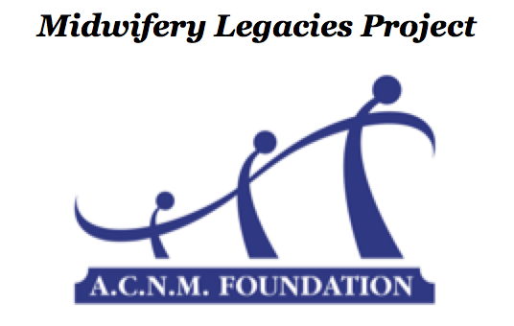
Twentieth Century Midwives – Student Interview Project
STUDENT APPLICATION FOR PARTICIPATION
INSTRUCTIONS: Complete this form and email it to the A.C.N.M. Foundation at fdn@acnm.org

Student Demographic Information
Student Name (first/last): ____________________________________________________________
Current Street Address: _________________________________________________
City: ________________________________ State: _______ Zip code: ___________
Telephone: _______________________ ACNM member number (required): _____________
Email Address: _______________________________________________________
Midwifery School: _____________________________________________________
Name of Supporting Faculty Member: _______________________________________
Supporting Faculty Member’s email address: ___________________________________
Expected Midwifery School Graduation Date (MM/YYYY): ___________________________

Choose one of the following options
____ | Option #1 | Match me with a midwife from the project database.  Specific requests for the matching process (e.g. geographic location, travel distance, etc): ___________________________________________  _____________________________________________________
____ | Option #2 | I am requesting approval to interview the following senior midwife:  Name (first/last): ________________________________________  Date of Birth (MM/DD/YYYY): ________________________________  Current Address: ________________________________________  City: ______________________ State: _____ Zip code: _________  Telephone: ____________________________________________  Email Address: _________________________________________  Midwifery School: _______________________________________  Midwifery School Graduation Date (MM/YYYY): ___________________

I have reviewed the project instructions and information packet and agree to the terms of participation in the 20th Century Midwife Student Interview Project. I agree to keep the project coordinator apprised of my progress and understand that I must notify the project coordinator, if for any reason, it becomes necessary for me to withdraw from the project prior to completion.

Student Signature: _____________________________ Date:____________

