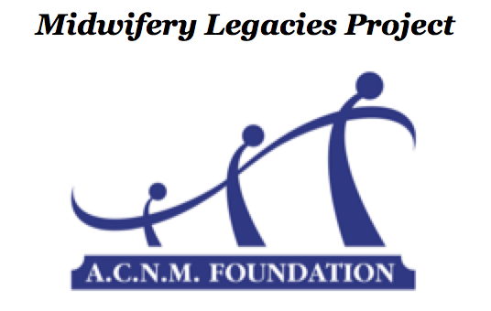
INSTRUCTIONS: To initiate the interview matching process, the interviewer
should complete the upper portion of this form and email it to the A.C.N.M.
Foundation at fdn@acnm.org:

Twentieth Century Midwives
Midwife-to-Midwife Interview Project
PROJECT APPLICATION

Interviewer Information
Name (first/middle/last):
Current Address:
City: State: Zip code:
Telephone (home): ( )
Telephone (cell): ( )
Email Address:
ACNM member number (required):
Midwifery School / Year of Graduation:
Other locations accessible and/or special requests for the matching process:

---------Section below to be completed after submission of the final interview project----------

Senior Midwife Interviewee Information

Name (first/middle/last/maiden): Current Address:
City: State: Zip code:
Telephone (home): ( )
Telephone (cell): ( )
Email Address:
Midwifery School / Year of graduation:

Rev. 8/2015

