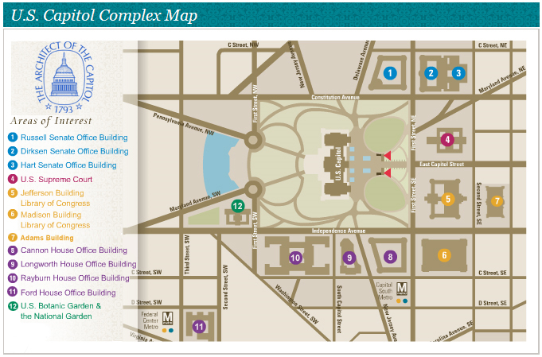
Bus Pick Up
Bus Drop Off
Essential Facts about Midwives

Midwives and Birth in the United States
- The American College of Nurse-Midwives (ACNM) is the professional association representing certified nurse-midwives (CNMs) and certified midwives (CMs) in the United States. According to the American Midwifery Certification Board, as of February 2015, there were 11,018 CNMs and 88 CMs. The vast majority of midwives in the United States are CNMs.¹
- In 2013, CNMs/CMs attended 320,983 births – a slight increase despite a decrease in total US births compared to 2012. In 2013, CNMs/CMs attended 92% of all midwife-attended births, 12% of all vaginal births, and 8.2% of total US births.² (2013 is the most recent year for which birth data are available from the National Center from Health Statistics.)

Midwifery Practice
- CNMs are licensed, independent health care providers with prescriptive authority in all 50 states, the District of Columbia, American Samoa, Guam, and Puerto Rico. CNMs are defined as primary care providers under federal law.
- Because CM is a newer, equivalent pathway to midwifery, it is not yet reflected in all state legislatures. CMs are authorized to practice in Delaware, Missouri, New Jersey, New York, and Rhode Island. CMs have prescription-writing authority in New York.
- While midwives are well-known for attending births, 53.3% of CNMs/CMs identify reproductive care and 33.1% identify primary care as main responsibilities in their full-time positions. Examples include annual exams, writing prescriptions, basic nutrition counseling, parenting education, patient education, and reproductive health visits.³
- In 2013, 94.6% of CNM/CM-attended births occurred in hospitals, 2.8% occurred in freestanding birth centers, and 2.6% occurred in homes.²
- More than 50% of CNMs/CMs list physician practices or hospitals/medical centers as their principal employers.⁴
- Medicaid reimbursement for CNM care is mandatory in all states. Medicare and most Medicaid programs reimburse CNMs/CMs at 100% of physician rates. The majority of states also mandate private insurance reimbursement for midwifery services.

Midwifery Education
- Standards for education and certification in midwifery are identical for CNMs and CMs.
- The Accreditation Commission for Midwifery Education (ACME) is the official accrediting body for CNM/CM education programs. There are 39 ACME-accredited midwifery education programs in the United States.⁵
- Approximately 82% of CNMs have a master's degree.³ As of 2010, a graduate degree is required for entry to midwifery practice as a CNM/CM.⁶
- 4.8% of CNMs have doctoral degrees, the highest proportion of all APRN groups.⁷

Midwifery Outcomes
“Provision of accessible quality midwifery services that are responsive to women’s needs and wants should be part of the design of health-care service delivery and should inform policies related to the composition, development, and distribution of the health workforce in all countries.”
The Lancet, 2014 ⁸

“The review concludes that most women should be offered midwife-led continuity models of care, although caution should be exercised in applying this advice to women with substantial medical or obstetric complications.”
Cochrane Reviews, 2009 and 2013 ⁹

“Based on this systematic review, there is moderate to high evidence that CNMs rely less on technology during labor and delivery than do physicians and achieve similar or better outcomes.” Women’s Health Issues, 2012 ¹⁰

- American Midwifery Certification Board
- CDC Vital Stats
- Fullerton J, Schuiling K, Sipe TA. Findings from the Analysis of the American College of Nurse-Midwives’ Membership Surveys: 2006–2008. Journal of Midwifery & Women’s Health 2010; 55: 299-307.
- ACNM Core Data Survey, 2010
- Accreditation Commission for Midwifery Education
- Mandatory Degree Requirements for Entry into Midwifery Practice, ACNM Position Statement, July 2009
- Fullerton JT, Sipe TA, and Schuiling KD, Demographic profiles of certified nurse-midwives, certified registered nurse anesthetists and nurse practitioners: reflections on implications for uniform education and regulation. Journal of Professional Nursing. Vol 25, No 3 (May-June) 2009.
- Jane Sandall, Hora Soltani, Simon Gates, Andrew Shennan, Declan Devane, “Midwife-led continuity models versus other models of care for childbearing women,” The Cochrane Collaboration, 2013, and Hatem M, Sandall J, Devane D, Soltani H, Gates S, “Midwife-led versus other models of care for childbearing women (Review),” The Cochrane Collaboration and published in The Cochrane Library 2009, Issue 3
- Meg Johantgen, PhD, RN a,*, Lily Fountain, MS, CNM, RN a, George Zangaro, PhD, RN b, Robin Newhouse, PhD, RN, NEA-BC a, Julie Stanik-Hutt, PhD, ACNP, CCNS, FAAN c, Kathleen White, PhD, RN, NEA-BC, FAAN, “Comparison of Labor and Delivery Care Provided by Certified Nurse-Midwives and Physicians: A Systematic Review: 1990 to 2008,” Women’s Health Issues, vol. 22, no. 1, 2012, pp. e73-e81.
- Petra ten Hoope-Bender, Luc de Bernis, James Campbell, Soo Downe, Vincent Fauveau, Helga Fogstad, Caroline S E Homer, Holly Powell Kennedy, Zoe Matthews, Alison McFadden, Mary J Renfrew, Wim Van Lerberghe, “Improvement of maternal and newborn health through Midwifery,” www.thelancet.com Published online June 23, 2014 http://dx.doi.org/10.1016/S0140-6736(14)60930-2.

Improving Access to Maternity Care Act of 2015 (H.R. 1209/S. 628)

Why this Legislation is Needed
- In 2013, there were approximately 3.93 million US births, a number that is projected to be more than 4.4 million in 2050. The population of women over the age of 15 is expected to grow by 36 million in that same timeframe. (CDC Vital Stats data and Census Bureau population projections)
- In 2013, there were a total of four maternal care providers (CNMs/CMs and OB/GYNs) for every 10,000 women (age 15+) in the country. (American College of Obstetricians and Gynecologists and American Midwifery Certification Board).
- The number of medical school graduates entering OB/GYN residencies has remained essentially flat for three decades. There were 1,163 first year OB/GYN residents in 1979. In 2014, there were 1,221. (William F. Rayburn, MD, MBA, FACOG, “The Obstetrician Gynecologist Workforce in the United States: Facts, Figures, and Implications, American Congress of Obstetricians and Gynecologists, 2011.)
- The number of graduates from midwifery education programs (CNMs/CMs) has been growing, but absolute numbers are still small relatively to population needs. In 1979, there were 192 new CNM/CM certificants. In 2014, there were 576. (American Midwifery Certification Board).
- The character of the OB/GYN workforce has gone through a dramatic transformation in the last four decades. In 1975, only 15 percent of first year OB/GYN residents were women. In 2013, that figure was 82.6 percent.
  - Female and male physicians balance their professional and personal lives differently. Women work fewer hours, work part time more often and retire several years earlier. This has significant ramification for workforce capacity in the coming years. (Rayburn, 2011).
- For millions of women, shortages of maternity care providers can result in long wait times for appointments and long travel times to prenatal care and/or birthing sites. Prenatal care has an impact on incidence of low-birth weight and premature births, which can have life long repercussions and costs.
- In 2011, 40 percent of US counties had no CNM/CM or OB/GYN. (HRSA’s Area Resource File)
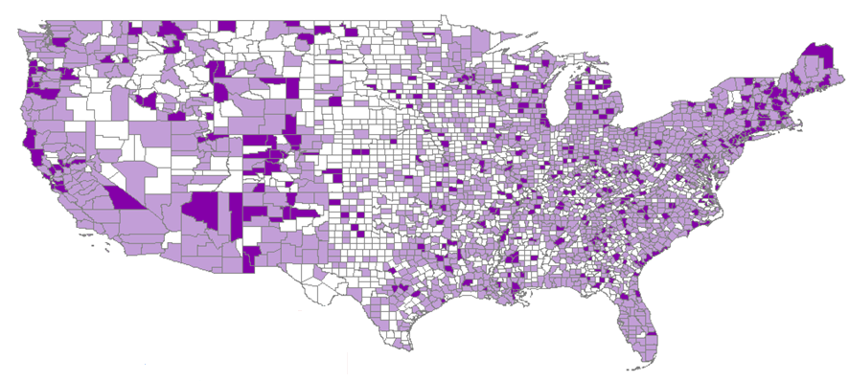

CNMs/CMs & OB/GYNs
per 100,000 Population

0
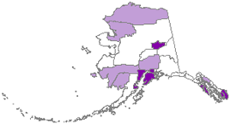
0.1 – 29.9
30.0 +

What this Legislation Would Do
- The “Improving Access to Maternity Care Act of 2015” would require the Health Resources and Services Administration (HRSA) to identify areas experiencing a shortage of full scope maternity care professionals and facilities with labor and delivery units (hospitals and birth centers).
- HRSA currently identifies three other types of shortage areas (primary care, mental health and dental care). There is thus an established mechanism for developing these area identifiers.

Impact on the National Health Service Corps
- HRSA fosters placement of health care professionals in currently designated shortage areas by providing scholarships and loan repayment through the National Health Service Corps (NHSC) to professionals who agree to work in shortage areas for a specified amount of time.
- CNMs/CMs and OB/GYNs can qualify for these programs, but their qualification is based on working in an area that has been identified as experiencing a shortage of primary care professions. These shortage areas may, but do not necessarily overlap with areas of the country experiencing shortages of maternity care providers.
- The new maternity care shortage area designation will allow HRSA to support through the NHSC those professionals whose expertise best aligns with that particular type of shortage experienced in a given area.
- The legislation does not create new expenditures; rather, it better targets existing expenditures.

Becoming a Co-Sponsor
- On March 3, 2015, the “Improving Access to Maternity Care Act of 2015,” (H.R.1209/S. 628) was introduced in the House by Rep. Mike Burgess (R-TX) and Rep. Lois Capps (D-CA) and in the Senate by Sen. Mark Kirk (R-IL) and Sen. Tammy Baldwin (D-WI). Bipartisan co-sponsorship has developed in both chambers.
- To cosponsor the House bill please contact Ms. Danielle Steele in Rep. Burgess’ office at Danielle.Steele@mail.house.gov or Ms. Devin McBrayer in Rep. Capps’ office at Devin.McBrayer@mail.house.gov. To cosponsor the Senate bill please contact Mr. Andrew Vogt in Senator Kirk’s office at Andrew_Vogt@kirk.senate.gov or Kathleen Laird in Senator Baldwin’s office at Kathleen_Laird@baldwin.senate.gov. You may also contact ACNM’s federal representative, Patrick Cooney at (202) 347-0034 x101 or via email at Patrick@federalgrp.com if you have questions regarding this issue.

Legislation on CNM Supervision of SNMs/Interns/Residents

Why this Legislation is Needed
- Interprofessional education, where students in one discipline receive instruction from providers working in other disciplines, has become much more common. This model benefits students by familiarizing them with the approaches, philosophy and skills of the various professionals with whom they will be working in a team environment throughout their careers. This is a good thing for patients.
- The prevalence of interprofessional education is likely to expand in the future. The American College of Nurse-Midwives and American College of Obstetricians and Gynecologists are engaged in a specific joint effort to expand the use of interprofessional education.
- Certified nurse-midwives (CNMs) and certified midwives (CMs) play a valuable role as educators in the nation’s teaching facilities across the nation.
- The Accreditation Council of Graduate Medical Education’s (ACGME) Program Requirements for Graduate Medical Education in Obstetrics and Gynecology, effective as of January 2008, highlights the role of CNMs supervising residents in part VI.D of the document. It states, “In the clinical learning environment, each patient must have an identifiable, appropriately credentialed and privileged attending physician (or licensed independent practitioner as approved by each Review Committee) who is ultimately responsible for that patient’s care. Any health professional with appropriate certification, e.g., Certified Nurse Midwife, Nurse Practitioner, Physician Assistant, can be listed as faculty.”
- Presently, teaching facilities are not explicitly allowed to bill the Medicare program for a midwife’s time spent in the supervision and instruction of medical interns and residents in the delivery of appropriate obstetrical and gynecological care. The Medicare statute is silent on the status of midwives as it relates to teaching facilities, while specifically allowing physicians to be reimbursed for the time they spend training interns and residents. This is a barrier to the implementation of interprofessional approaches to educating maternity care providers.
- Officials at the Centers for Medicare and Medicaid Services have told ACNM that a statutory modification would need to be made for the agency to pursue rules to allow payment to teaching facilities for supervisory services of teaching midwives.

What this Legislation Would Do
- H.R. XXXX would modify the Medicare statute to permit payment to hospitals for the services of CNMs who supervise student midwives and OB/GYN interns and residents.

Becoming a Cosponsor
- On June XX, 2015, the “ACT,” (H.R. XXXX) was introduced in the House by Rep. Lucille Roybal-Allard (D-CA) and Rep. XX (R-XX).
- To cosponsor the House bill please contact Ms. Debbie Jessup in Rep. Roybal-Allard’s office at Debbie.Jessup@mail.house.gov. You may also contact ACNM’s federal representative, Patrick Cooney at (202) 347-0034 x101 or via email at Patrick@federalgrp.com if you have questions regarding this issue.

Midwifery and Addressing the Shortage of Maternal Care Providers

Shortages in the Maternal Care Workforce
- In 2013, there were approximately 3.93 million US births, a number that is projected to be more than 4.4 million in 2050. The population of women over the age of 15 is expected to grow by 36 million in that same timeframe. (CDC Vital Stats data and Census Bureau population projections)
- In 2013, there were a total of four maternal care providers (CNMs/CMs and OB/GYNs) for every 10,000 women (age 15+) in the country. (American College of Obstetricians and Gynecologists and American Midwifery Certification Board).
- The number of medical school graduates entering OB/GYN residencies has remained essentially flat for three decades. There were 1,163 first year OB/GYN residents in 1979. In 2014, there were 1,221. (William F. Rayburn, MD, MBA, FACOG, “The Obstetrician Gynecologist Workforce in the United States: Facts, Figures, and Implications, American Congress of Obstetricians and Gynecologists, 2011.)
- The number of graduates from midwifery education programs (CNMs/CMs) has been growing, but absolute numbers are still small relatively to population needs. In 1979, there were 192 new CNM/CM certificants. In 2014, there were 576. (American Midwifery Certification Board).
- The character of the OB/GYN workforce has gone through a dramatic transformation in the last four decades. In 1975, only 15 percent of first year OB/GYN residents were women. In 2013, that figure was 82.6 percent.
  - Female and male physicians balance their professional and personal lives differently. Women work fewer hours, work part time more often and retire several years earlier. This has significant ramification for workforce capacity in the coming years. (Rayburn, 2011).
- For millions of women, shortages of maternity care providers can result in long wait times for appointments and long travel times to prenatal care and/or birthing sites. Prenatal care has an impact on incidence of low-birth weight and premature births, which can have life long repercussions and costs.
- In 2011, 40 percent of US counties had no CNM/CM or OB/GYN. (HRSA’s Area Resource File)
- ACOG has projected a shortage of between 15,723 – 21,723 OB/GYNs by 2050.

Midwifery’s Role in the Solution
- CNMs/CMs specialize in fostering normal physiologic birth, which most women are able to experience.
- In 2013, CNMs/CMs attended 8.2% of all US births. (CDC Vital Stats) CNMs/CMs could attend a larger proportion of normal physiologic births, freeing OB/GYNs to use their specialized skills to assist women with more significant complications.
  - Two Cochrane reviews (2009 and 2013), a US systematic review of the literature (2012) and The Lancet (2014) have examined outcomes data associated with midwifery care and all endorsed the use of midwifery care as a core part of maternal care systems.
- Many countries make much more significant use of midwives. Typically, in the developed world, there are approximately 2.5 midwives per OB/GYN. (Midwifery in Europe: An Inventory in fifteen EU-member states,” and Narumi Eguchi, “Do We Have Enough Obstetricians? – A survey of the Japan Medical Association in 15 countries,” JMAJ, May/June 2009, vol. 52, no. 3, pp. 150-157.)
- Educating CNMs/CMs is relatively swift and cost effective. Educational programs typically require 2 years of post-baccalaureate graduate-level study and cost on average around $54,000.

Obstacles to Increasing the Nation’s Midwifery Workforce
- Midwifery education programs have consistently identified the challenge of securing a sufficient number of clinical sites for precepting student midwives as the primary bottleneck in the process of educating and preparing new CNMs/CMs.
- Providers who agree to precept midwifery students consistently report that doing so reduces their productivity and thus their ability to generate income for their practice. They face the trade off of reducing their revenue or extending their work hours.
- Sixty-two percent of preceptors receive no remuneration in return for agreeing to take on this important responsibility. (Elaine Germano, CNM, DrPH, et al., “Factors that Influence Midwives to Serve as Preceptors: An American College of Nurse-Midwives Survey,” Journal of Midwifery & Women’s Health,” Vol. 59, No. 2, March/April 2014, pp. 167-175.)
- A modest estimate of the cost to a preceptor site of taking on a single student is approximately $6,000.

Current Support for Midwifery Education
- In 2014, the National Health Service Corps (NHSC) provided funding to 40 CNMs through loan repayment or scholarship programs. Total NHSC spending on midwives during 2014 was $1,978,257. This money is very helpful, but is directed to individuals and not their education programs and thus is not available to the programs to use for purposes of securing preceptor sites.
- In 2014, the Graduate Nursing Education demonstration program was able to support preceptor sites for only 4 student midwives. Total support for these sites amounted to $18,000.
- There were approximately 2,200 midwifery students in 2014, for whom hundreds of preceptor sites are needed.

What is Needed?
- A minimal annual investment could offset preceptor site costs and help the nation’s midwifery education programs prepare a sufficient number of midwives to meet what will be increasingly critical maternal care needs in the coming years.
- ACNM will be presenting policymakers with specific recommendations regarding support for preceptor sites in the near future.

