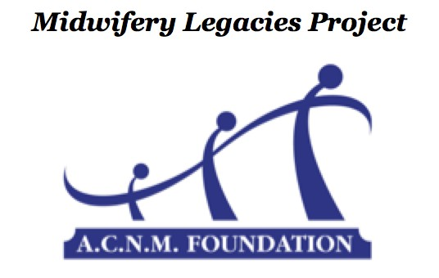
Twentieth Century Midwives – Student Interview Project
PROJECT APPLICATION
2014 – 2015

INSTRUCTIONS: To initiate the interview matching process, the student should complete the upper portion of this form and email it to BOTH project coordinators:

Student Interviewer Information
Name (first/middle/last):
Current Address:
City: State: Zip code:
Telephone (home): ( )
Telephone (cell): ( )
Email Address:
ACNM member number (required):
Undergraduate Degree: Undergraduate School: Midwifery School:
Expected Midwifery School Graduation Date (MM/YYYY): /
Other locations accessible and/or special requests for the matching process:

----------Section below to be completed at time of interview project submission-----------

Senior Midwife Interviewee Information

Name (first/middle/last/maiden): Current Address:
City: State: Zip code:
Telephone (home): ( )
Telephone (cell): ( )
Email Address:
Undergraduate Degree: Undergraduate School:
Midwifery School:
Midwifery School Graduation Date (MM/YYYY): /

7

